Mission 3 Assignment | Name:
Pre-Mission Preparation
All electronic devices have circuit boards inside, and a way to get input and give output. Look at the CodeBot. What are some ways to give input to the CodeBot?
What are some ways to receive output from the CodeBot?
Mission 3 Checks
Objective #1
What is the code to turn on a single LED?
Objective #2  Number the user LEDs: | 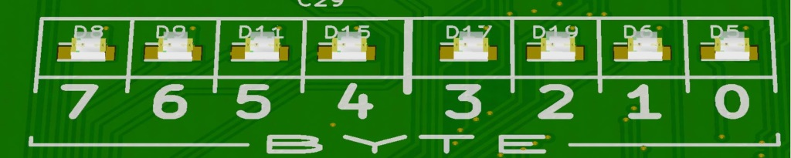
Objective #3
Which user LEDs are turned on with this code:
0b01100110
Objective #4
Besides the user LEDs, what are the other LEDs you can program?
Objective #5
What is sequential code?

What is the algorithm for blinking an LED?
Post-Mission Reflection
What is something you looked forward to doing in future missions?

